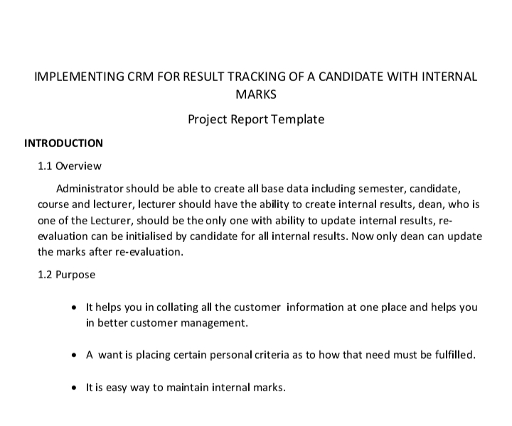

2.Problem Definition And Design Thinking

2.1 Empathy Map

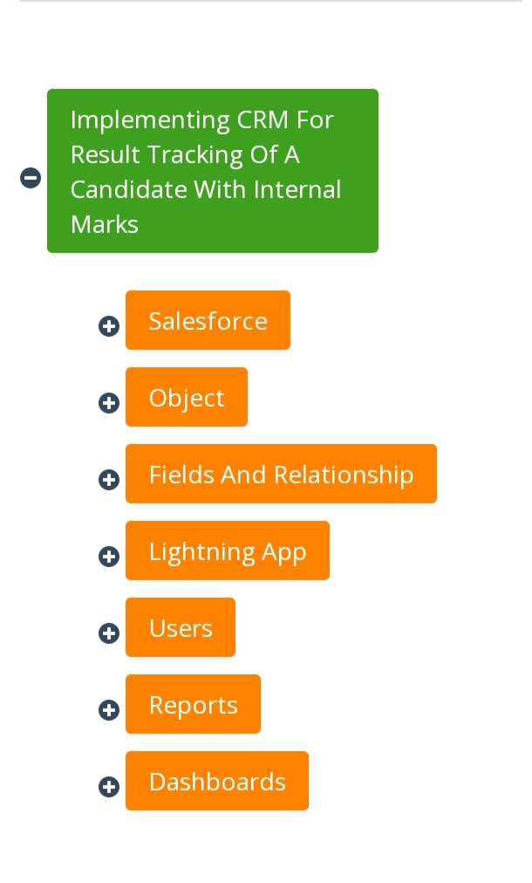

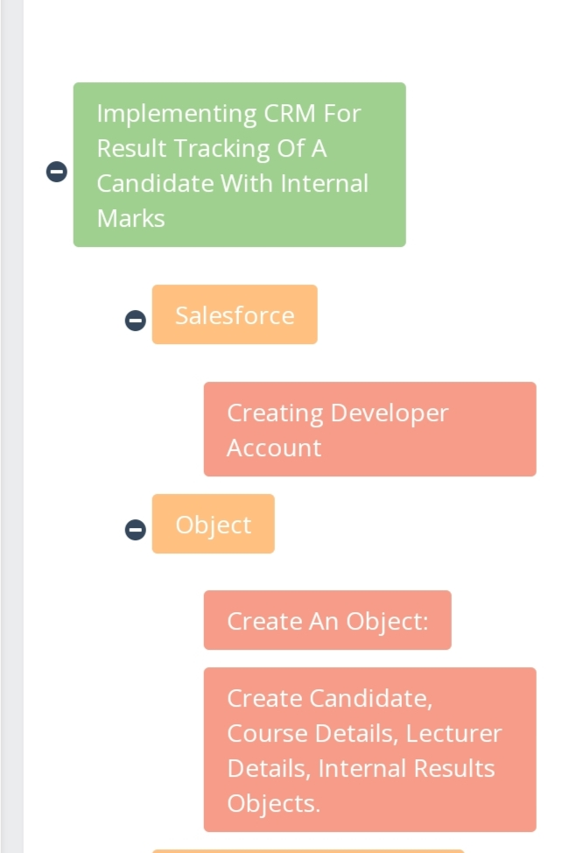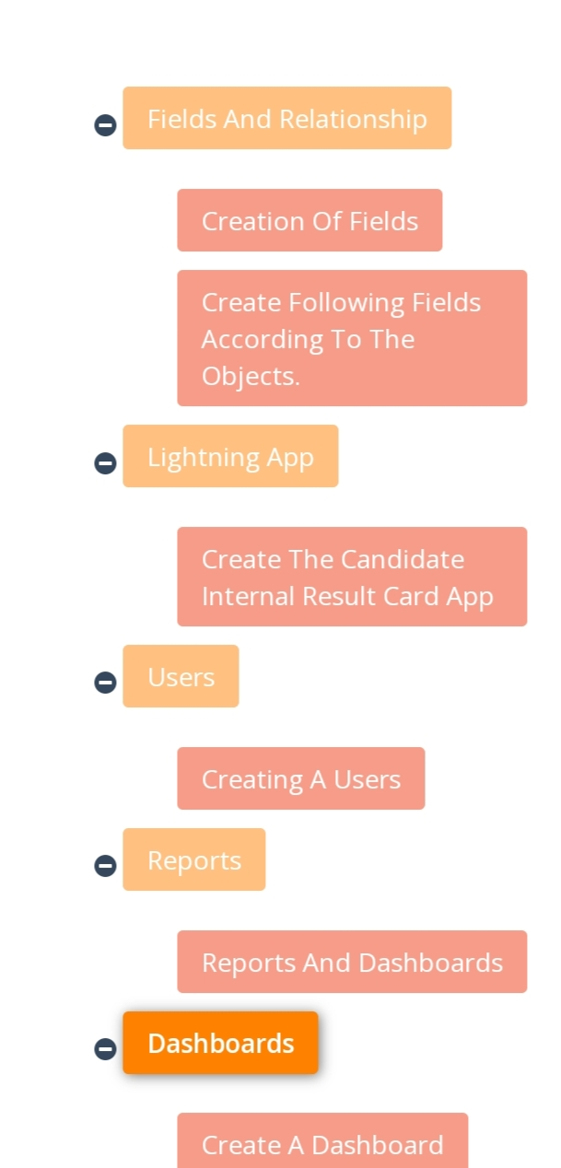

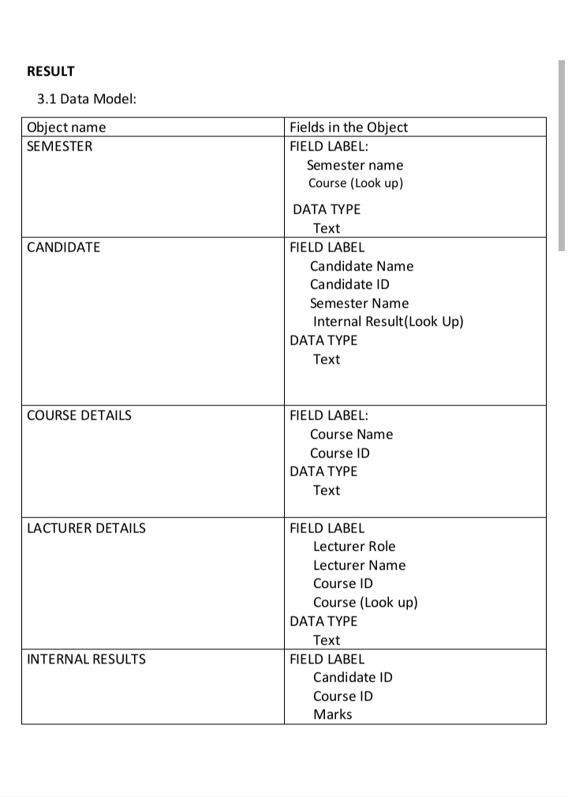

|  |  |
| --- | --- |
|  | DATA TYPE TEXT |

3.2 ACTIVITY & SCREENSHOT

CREATION SALESFORCE ORG

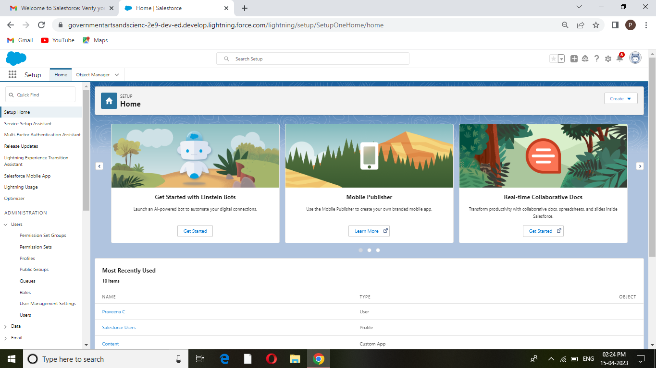we have create an developer account for salesforce account.Salesforce is your customer success platform

Our mail id and name are given to get developer account.

CUSTOM OBJECT

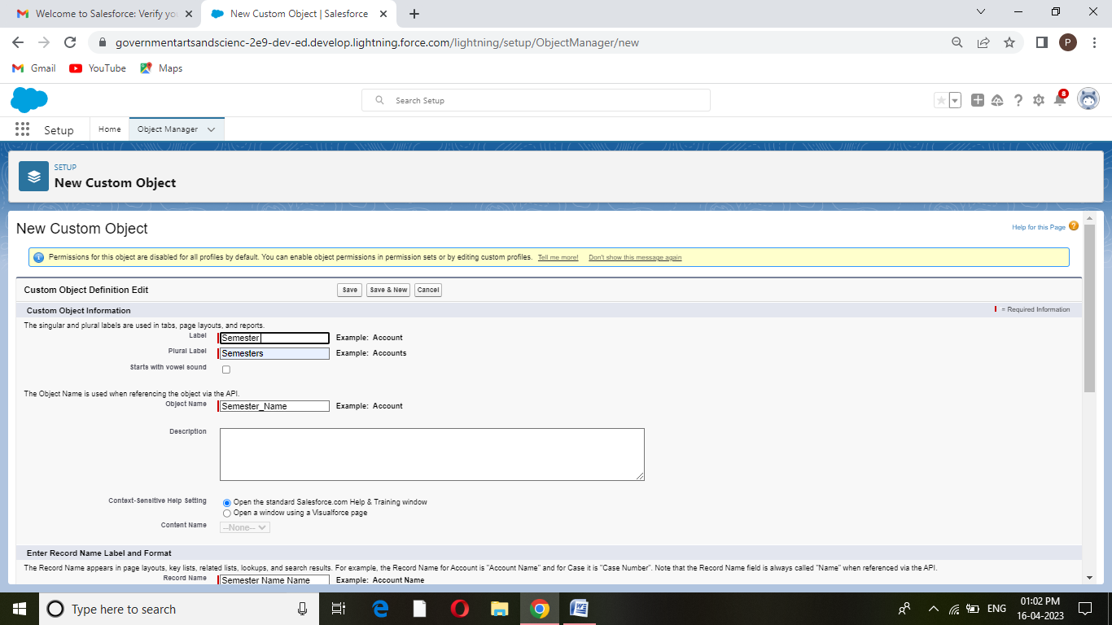 TAB:

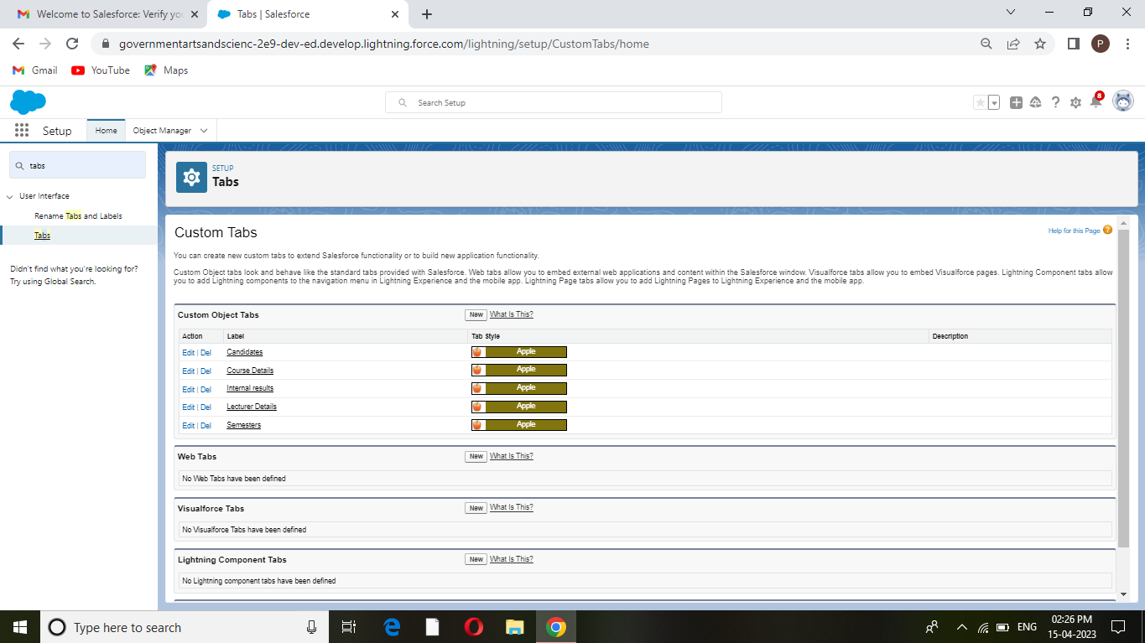Creation of objects for candidate internal result card ,for this candidate internal result card was need to create 5 objects that are Semester, Candidate,course Details ,Lecturer Details,Internal Results.

FILEDS AND RELATIONSHIPS

CREATION OF FILDS:

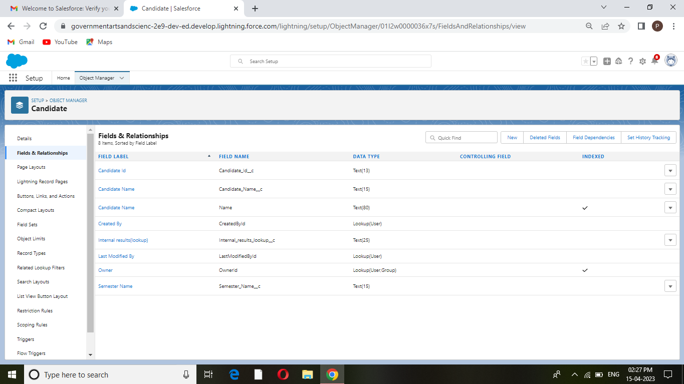

Relationship are create custom relationship fields on an object.This is done for the users to view,records,they can also see and access related date.

LIGHTNING APP

CREATE THE CANDIDATE INTERNAL RESULT CARD APP

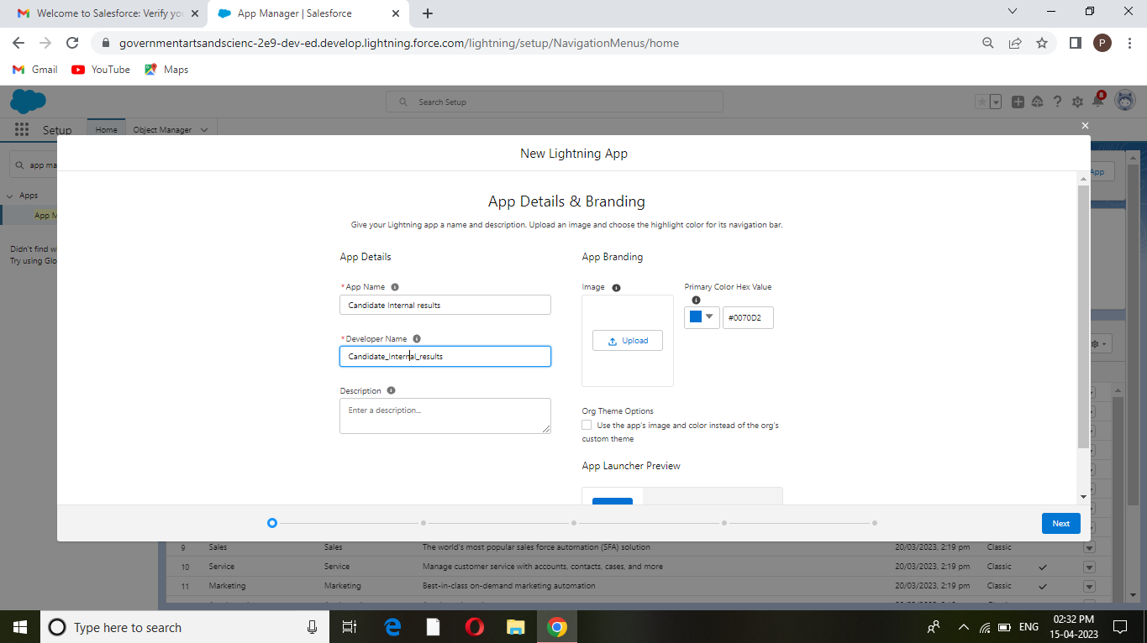

App in salesforce are a group of tabs that help the application function by working together as a unit. We have Created the lightning app of candidate internal result card.

USERS

CREATING A USERS:

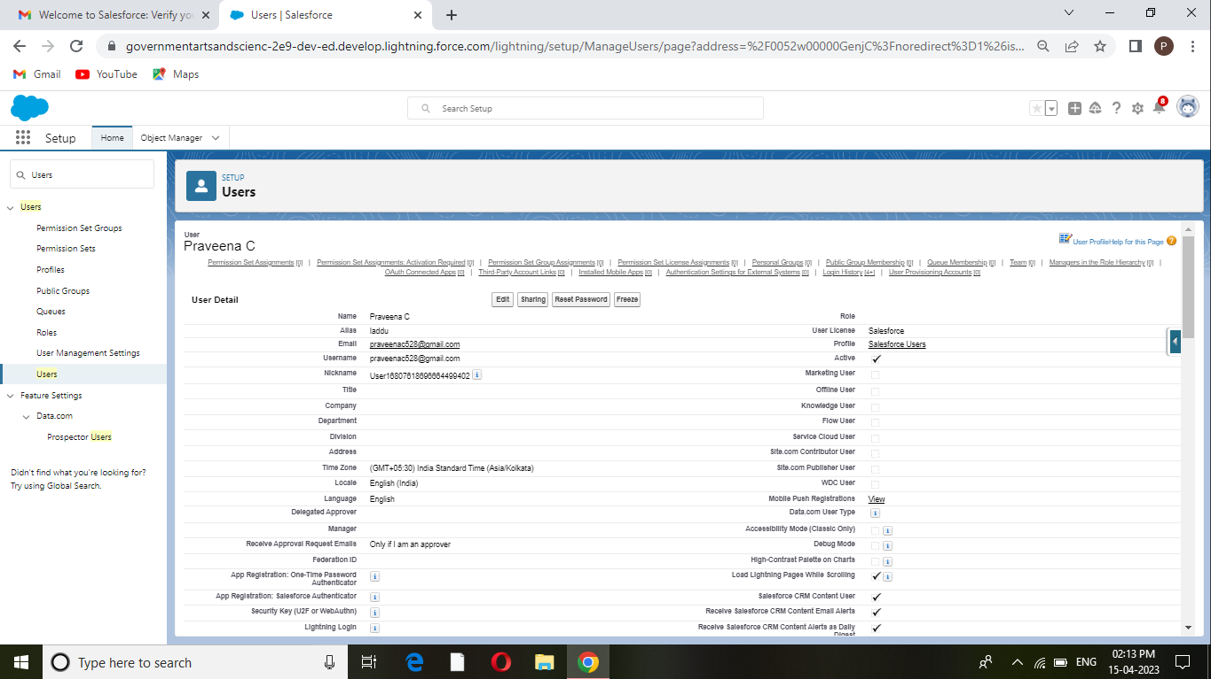Every user in salesforce has a user account.Click setup enter user,enter the details,we create a new user.

REPORTS:

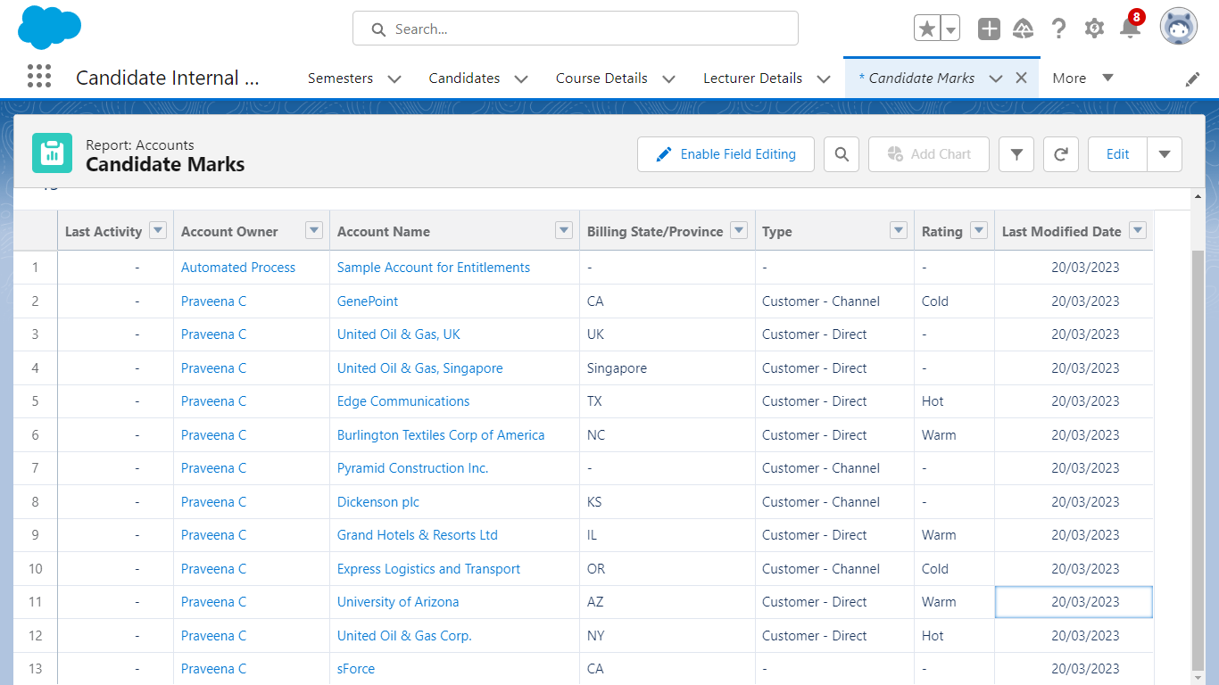

A report is a list of record that meet the criteria you define Its is displayed in salesforce in the form of rows and columns,and can be filtered,grouped,or displayed in a graphical chart.Every reports is stored in a folder.

DASHBOARDS:

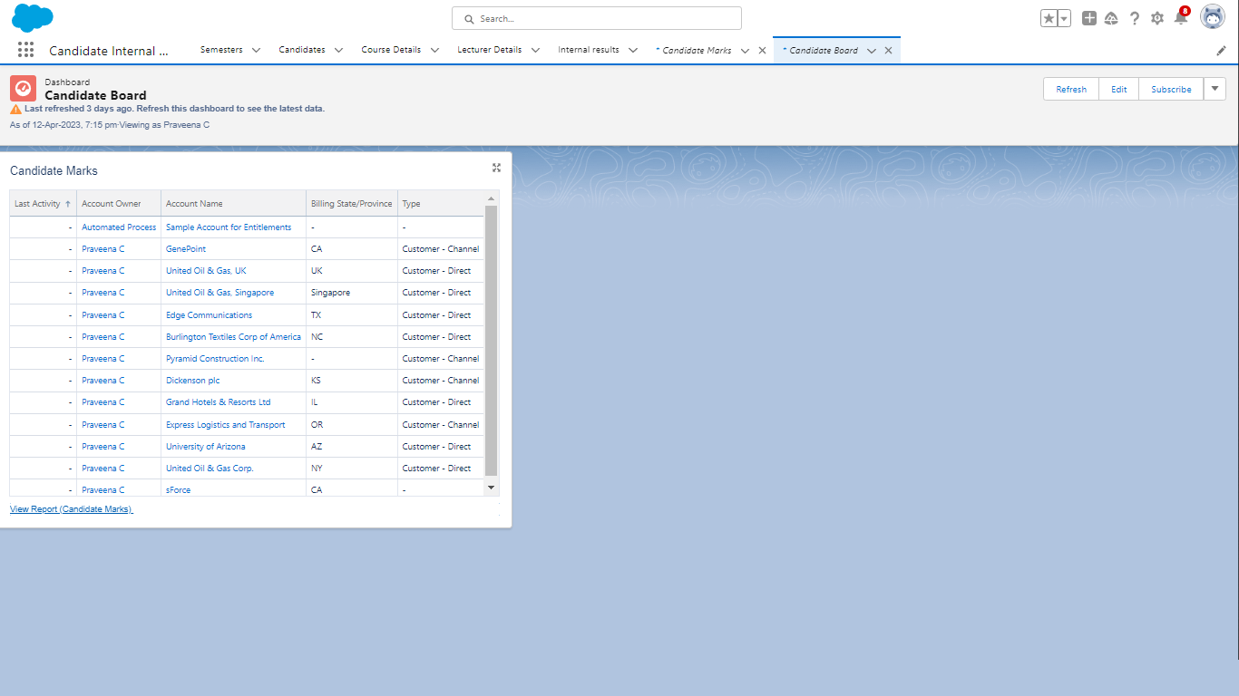

4.TRAILHEAD PROFILE PUBLIC URL:

Team Lead:https://trailblazer.me/id/upraveenac

Team Member 1:https://trailblazer.me/id/premr34

Team Member 2:https://trailblazer.me/id/strailhead

Team Member 3:https://trailblazer.me/id/vengs6

5.ADVANTAGE & DISADVANTAGE:

ADVANTAGE:

* CRM made targeting and marketing simple.
* Improve devision making and productivity.
* Tracking of customer data.
* Customer are engaged across multiple channel.

DISADVANTAGE:

* Loss of collected information or records.
* Not suitable for every business.
* Experience based in all thestages.
* Centralized data is at stake
* Lots of security concerns.

6.APPLICATONS:

This application is used by the government agency or visa process.

7.CONCLUSION:

This concluded,that the existing implementing CRM for result tracking of candidate with internal marks becames more result we add this type of feature with the help of salesforce.

8.FUTURE SCOPE:

We see the Future scope of this Project would save that time of both people the applicants and Recrultess.